Mehmet Izol

Professor Cleveland

COMP 3324

Lab 6 – Splunk

3/12/2023

Splunk – Intro

My output Image:

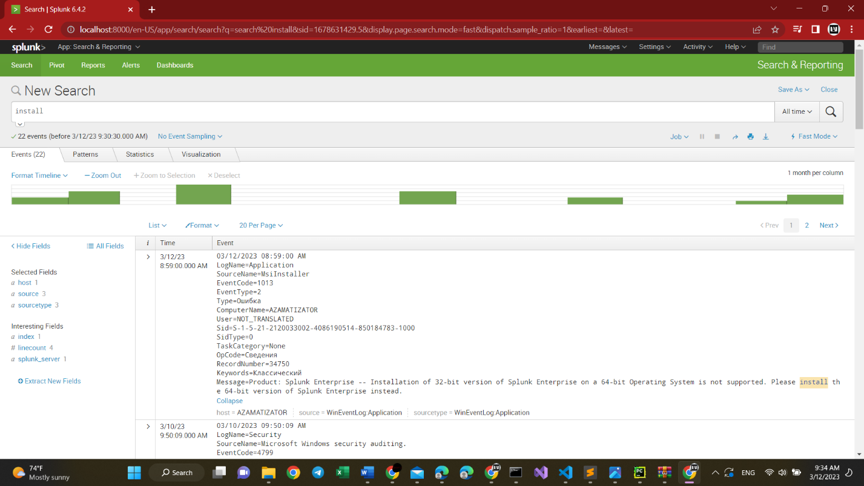

I used my Friend Azamat Salamatov’s laptop, His Windows. Because I have MacOS.

What new I learned:

1. Splunk helps us to monitor, analyze and search date, and condition of our computer.
2. Here we searched some data from the processor
3. And some “install” results
4. Before, we monitored and configured some setting for processor.